### 

**NAME:** Neev Shah

**USN:** 22BTRCL107

**CLASS:** AIML-C

**DATE:** 30th May 2024

# 

# **Python-SQL Task**

**Please complete the following task individually:**

**1. Create a database called as "Library" using SQL queries executed through MySQL workbench.**

CREATE DATABASE Library;

USE Library;

**2. Create a table in this dataset called as "Books" using the same MySQL workbench, include following columns in this table:**

**a. bookID**

**b. bookName**

**c. USN**

**d. Author**

**e. price**

CREATE TABLE Books(

bookID INT PRIMARY KEY,

bookName VARCHAR(255),

USN VARCHAR(255),

Author VARCHAR(255),

price DECIMAL(10,2) );

**3. Insert at least 5 records in this table through SQL queries using MySQL workbench.**

INSERT INTO Books(bookID, bookName, USN, Author, price) VALUES

(1001, 'Book_One', 'USN001', 'Author1', 2000),

(1002, 'Book_Two', 'USN002', 'Author2', 3000),

(1003, 'Book_Three', 'USN003', 'Author3', 3500),

(1004, 'Book_Four', 'USN004', 'Author4', 4000),

(1005, 'Book_Five', 'USN005', 'Author5', 5000);

**THE PYTHON CODE:**

# 22BTRCL107 - NEEV SHAH

import mysql.connector

mydb = mysql.connector.connect(

host='localhost',

user='root',

password='1234',

database='Library'

)

cursor = mydb.cursor()

**4. Write a python program that fetches all these data from this table directly through python program itself. Show the output on IDLE.**

#STEP-4: Fetch all the records

print("Fetching all records:")

cursor.execute("SELECT * FROM Books")

records = cursor.fetchall()

for record in records:

print(record)

**OUTPUT:**

**5. Write another python program that updates a record in this table directly through python program. Show the output on IDLE.**

#STEP-5: Update the price of the book with ID 1001

print("\n\n\nUpdating the price of the book with ID 1001:")

book_id = 1001

new_price = 2200

cursor.execute("UPDATE Books SET price = %s WHERE

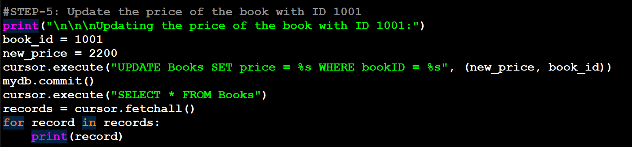 bookID = %s", (new_price, book_id))

mydb.commit()

cursor.execute("SELECT * FROM Books")

records = cursor.fetchall()

for record in records:

print(record)

**OUTPUT:**

**6. Write another python program that deleted a record in this table directly through python program. Show the output on IDLE.**

#STEP-6: Delete the book with ID 1

print("\n\n\nDeleting the book with ID 1001:")

book_id_2 = 1001

cursor.execute("DELETE FROM Books WHERE bookID = %s", (book_id_2,))

mydb.commit()

cursor.execute("SELECT * FROM Books")

records = cursor.fetchall()

for record in records:

print(record)

**OUTPUT:**

**AT LAST:**

**(You can also use one python program and execute these all tasks.)**

**THE ENTIRE CODE:**

**ENTIRE OUTPUT:**

